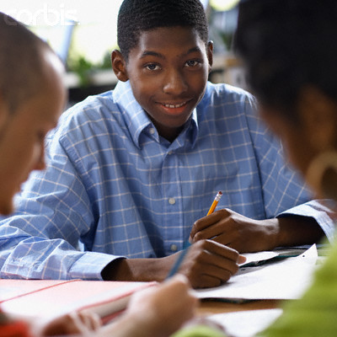

Cooperative Learning for Middle School Students with Disabilities
Clifton is a 7th grade student with autism who is included in the general education classroom. He is high functioning, has a good attitude, displays some hyperactivity, and is easily distracted.
During recent group activities in science class Clifton was observed sitting on the physical periphery of the arrangement and not socially interacting with typically developing students.
Sometimes students comment on Clifton:
“I don’t want to work with him, He just sits there and taps a pencil all class”
“He never finishes his work”

This is what the observed situation may suggest so far.

Clifton is not accepted by his typically developing peers.
Clifton doesn’t know how to interact.
Clifton is not assigned a contributing role within the group.
You must do something to facilitate the inclusion of Clifton into the general education classroom.
The positive effect of Cooperative Learning is extremely important because students with disabilities are at risk for peer rejection and alienation.

Meet Clifton:

What is Cooperative Learning
How can you increase the levels of social and task engagement for a student with a disability? How can you create a more democratic, inclusive middle school?
Cooperative learning is one of the most frequently recommended strategies for effecting the inclusion of students with disabilities in regular education classrooms.
Cooperative learning is a peer-mediated, instructional arrangement:
“in which small groups or teams of students work together to achieve team success that promotes’ the students’ responsibility for their own learning as well as the learning of others”(1).
You can use cooperative learning as away to encourage middle school students to engage with one another. By the nature and structure, members of cooperative groups are forced to work with, and not against one another (9).

Contents
Clifton Case Study 1
Cooperative Learning 1
So What: Coop Learn 1
Five Elements 2
Now What: Implement 2
Teach Process Skills 3
A Few Questions 3
Troubleshooting 3
Learn More 4
Informative websites 4

“Students in cooperative settings tend to accept students with disabilities more readily than they do in other settings (2).”

There are many reasons for employing cooperative learning as an inclusion strategy. First, it has been found to increase task and social engagement between students with disabilities and typically developing peers. Second, it can increase academic achievement for all students (1).Third, it appeals to teachers because it addresses diverse educational goals within a single approach (i.e. social and academic). Fourth, when students are working towards a common goal they are more motivated to help each other. Fifth, it promotes better attitudes towards teachers and schools (2).

So What: Cooperative Learning
The five necessary elements of cooperative learning include: positive interdependence, individual accountability, promotive interaction, social skill training, and group processing (5). Let’s take a look at these elements: Positive Interdependence means that you help the group identify a goal. Students are instructed to support each other because each member must learn the material. Individual Accountability means that we limit the group size, give oral exams & quizzes. Promotive Interaction is teaching students how to overcome problems. Social Skills we teach may include: work together, talk politely, trust, and conflict management. Group Processing allows students to reflect and identify ways to improve their interactions (1).

Cooperative Learning

Now What: Implement Coop Learning
In over 375 studies synthesized by Johnson & Johnson results suggested that students in cooperative learning settings performed better than students in competitive or individualistic setting(2).

Page 2 of 4

Cooperative Learning

Now What: Implement Coop Learning

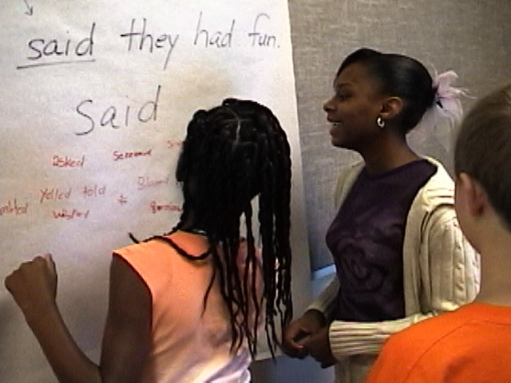
You can start to design cooperative learning by selecting a learning target such as identifying the anatomy of the circulatory system. First, you will select a learning format that includes one of the following, group performance (product or performance meet criteria), inquiry based (collaborative research), jigsaw (group learns skill then teaches skill to different group). Second, you will design a task structure. The task design elements that need to be determined include: a) the size of the group, b) the composition of the group, c) potential roles for group members. Three or four members are typically optimal, including one student with a disability (3).

Mixed ability is the preferred group composition when working with a student with a disability. Select students that have evidenced acceptance for students with a disability. Assign students roles within the group (1). First, it provides students a clearer sense of what to do in the process. Second, assigned roles make it more likely that the necessary roles and duties will be ultimately be performed. Here are some typical roles that can be useful in various cooperative learning activities, manager, recorder, reader, timer. Design a central role for the student with a disability. You can arrange the desks in a pod shaped (i.e. 4 students each at a desk facing each other) (6).

One physical arrangement you can use for cooperative You can carefully select the TD students for the group.
You can designate a central role to the student with a disability (i.e. recorder).
You can use structured tasks (i.e. worksheets, research project).
You can teach and reinforce social skills.
You can ensure critical components are included.
You can monitor for effectiveness.
You can be trained on successful cooperative learning implementation (3).

Page 3 of 4
Cooperative Learning
You can teach students the process skills for cooperative learning. These skills include how to actively listen, how to resolve conflict, how to communicate concerns, how to make decisions, how to perform a role, and how to share. For active listening teach how to make eye contact and ask to repeat. For conflict resolve teach emotion control, and I messages to lessen personal attacks. For communicating concerns teach not making a non-constructive negative judgment about the idea (e.g., “that idea is stupid.”), and opinion phrases with I-message language (i.e., I think, I feel, my idea, this is only my opinion, etc.). For decision making teach students a process for democratic decisions (2).

Now What: Teach Process Skills

The group leader can open the floor to discussion, when all sides have been heard call for a vote. Develop a compromise. Ask for ideas to combine ideas to include more students needs and desires. For role performing teach what constitutes the successful execution of their role. Create a written job description for the common roles that you find yourself using during cooperative learning. You provide the clarity that only words can. Some students would rather read the information privately than have to ask. For sharing teach students by helping them practice asking nicely, taking turns, looking for others who might need the item that they have just finished using (2).

Now What: Teach Process Skills

If you find that all but one or two groups are functioning properly keep in mind these three guidelines: (1) groups on task need the teacher as a source of encouragement, and reinforcement for being on task, (2) a group or two that is off task that needs help, and (3) the class is watching and learning how you deal with the on and off task group. A problem scenario might be that one student is instigating the problem. A intervention: we can do this, how can I help? What do they need as a result? – Information and clarity of the task. Give a clear message, say, I know you can do this, I expect you to do this, so stop whatever game you are playing and contribute to your group (2).

Now What: Troubleshooting

A Few Questions to Ask Yourself Before Beginning:

What are my learning targets?

Can the objectives I am trying to teach be accomplished in a collaborative form?

What benefits will the cooperative aspect bring to learning?

What will need to change about my approach to teaching and management?

Now What: Troubleshooting
If a whole group is having trouble working together, keep the ownership of the problem on the students, and provide interventions that provide choices and consequences. All the while keep your intervention anger free and constructive. You can use the following intervention. What is the problem?

This should assume that the students can succeed if they just have a better sense of what they are doing. It may be helpful to begin each interaction with a sense of the result we need to achieve before we walk away. What do they need as a result? – Support to help them accomplish their task (2).

[1] Grey, I.M., Burton, C., Honan, R., McGuinnes, R., & Daly, M. (2007). Co-operative learning for children with an autism spectrum disorder (ASD) in special class settings: An exploratory study. Educational Psychology in Practice. Vol. 23, No. 4, pp. 317-327.

[2] Johnson, D. W., Johnson, R., & Holubec, E. (1998). Cooperation in the classroom, (7th ed.). Edina, MN: Interaction Book Company.
Book by leading researchers in cooperative leaning.

[3] Jenkins, J. R., Antil, L.R., Wayne, S.K. & Vadasy, P.F. (2003). How cooperative learning works for special education and remedial students. Exceptional Children., 69 (3), 279-92.
Students with disabilities and cooperative learning.

[4] Jenkins, J.R., & O’Connor, R.E., (2003) Cooperative learning for students with learning disabilities: evidence from experiments, observations, and interviews. Handbook of Learning Disabilities. New York: Guilford.

[5] McMaster, K.N. & Fuchs, D. (2002). Effects of cooperative learning on the academic achievement of students with learning disabilities. Learning Disabilities Research and Practice., 17 (2), 107-11
An article regarding research into practice.

[6] Murphy, E., Grey, I.M., & Honan, R. (2005). Co-operative learning for student with difficulties in learning: a description of models and guidelines for implementation. British Journal of Special Education. Vol. 2, No.3, pp. 157-164.

[7] Oortwijn, M. B., Boekaerts, M., Vedder, P., & Fortuin, J., (2008). The impact of a
cooperative learning experience on pupils’ popularity, non-cooperativeness, and
interethnic bias in multiethnic elementary schools. Educational Psychology. Vol. 28, No. 2, pp. 211-221. Study on specifics of multiethnic cooperative learning practice.

[8] Piercy, M., Wilton, K., & Townsend. M., (2002). Promoting the Social Acceptance of Young Children with Moderate-Severe Intellectual Disabilities Using Cooperative Learning Techniques. American Journal of Mental Retardation. Vol. 107, No. 5, pp. 352-360.

[9] Sapon-Shevin, M., (1994). Cooperative learning and middle schools: What would it take to really do it right? Theory into Practice. Vol. 33, No. 3, pp. 183-190.

First choose a short title for your newsletter— something like "School News," or “Back to School.” As you choose the title, also take time to think about the newsletter’s theme. What important messages do you want to send parents and families?
Next, establish how much time and money you can spend on your newsletter. These factors will help determine how frequently you publish the newsletter and its length.
Use the body of your school newsletter to keep parents apprised of major assignments and class events.

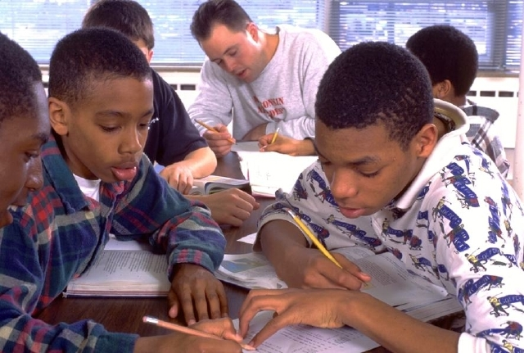
http://www.cooperation.org/pages/overviewpaper.html.
Overview of cooperative learning.
http://www.kidsouorce.com/NICHCY/
Articles and information on various disabilities and special education.
http://www.co-operation.org/pages/conflict.html
Teaching conflict resolution.

http://www.co-operation.org/index.html#newsletters
Newsletters for cooperative learning, link at bottom of page.
http://www.ldonline.org/article/5932
Web article for teaching math to students with disabilities using cooperative learning.
http://www.intime.uni.edu/coop_learning/ch8/default.htm
Conducting a cooperative assessment.

The purpose of a newsletter is to provide specialized information to a targeted audience. A school newsletter can be a great way to develop a strong relationship with parents.
First choose a short title for your newsletter— something like "School News," or “Back to School.” As you choose the title, also take time to think about the newsletter’s theme. What important messages do you want to send parents and families?
Next, establish how much time and money you can spend on your newsletter.

Bibliography

Informative Websites for Continued Education

Cooperative Learning Newsletter Developed
by Brent Lopick,
University of Pittsburgh

